30 Seconds of Work (4/27/2020)
Directions are to use a timer or have someone count for you all the way up to 30 seconds. You will count how many of each exercise you can do in that 30 seconds and record it here. Take 2-3 minutes of rest between each exercise. You will do two rounds of this. When completed record the highest number for each exercise on the space provided. (You only have to do this the day you see me but if parents want/allow you can do this throughout the week.)

- Flutter Kicks in place Many completed______________
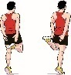
- Arm Circles ( Forwards) Many Completed______________
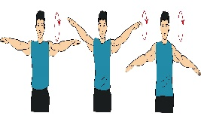
- Squats Many Completed______________
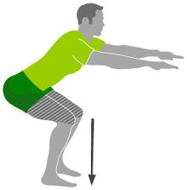
- Arm Circles ( Backwards) Many Completed_____________

- High Knee Runs in place Many Competed_____________
