8th Grade Science Syllabus 2019-2020
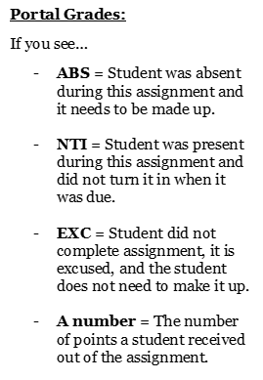
CONTACT INFORMATION:
Teacher: Ms. Broach
Email: hbroach@newlifeacademyga.com
Office Hours: Wednesday 3:30-4:15 pm
My “office hours” are available for students to: re-teach, make up tests/quizzes, receive extra help or practice on Inspire or IXL, or ask questions about their grades. Students must make an appointment by emailing me.

Grade Weights for Each Semester:
25% - Projects
35% - Classwork/Labs/Inspire
20% - Quizzes/Tests
10% - Final Exam (written & graded by Gwinnett County)
5% - Homework/IXL
5% - Interims (written & graded by Gwinnett County)

*Parent Portal will be updated weekly for parent/guardian convenience.*
Students are encouraged to check their grades regularly and ask questions that they might have about their grades. Do not wait until the end of the semester to do this!
Resources:
Inspire, IXL, NLAE website, class handouts & notes.
Organization will be extremely important for this class since content is coming from a variety of sources.

Absences/Tardy Policy:
If a student misses a test or quiz, they must make it up the first day that they return to school. According to the handbook, students with unexcused absences will be given a zero on any classwork they have missed. Homework can still be turned in for credit. In the event that a student has an excused absence and has brought a written excuse, they can meet with me during office hours to catch up on classwork.
Students have 3 minutes to change in between class. Once class has begun, teachers will lock their doors and students will be considered tardy. Students will be allowed in the classroom after their tardy has been marked. It is the student’s responsibility to make it to class on time – and they can’t learn if they’re not in class!
Retake Policy:
All students that score below a 90% on a test will be eligible for a retake.
Students may choose two retakes per semester.
The highest a student can receive on any retake is a 90%.
IXL: Students will need access to the internet to complete homework assignments through IXL. This website provides an additional support for students to continue developing science skills covered in class. IXL provides an individualized learning experience with immediate feedback. If students do not have access to technology, please see me to create an alternative assignment or coming

Inspire: A unified, three-dimensional approach that helps students develop key skills like collaboration, communication and problem solving. Inspire Science is designed to spark students’ interest and empower them to ask more questions, think more critically, and generate innovative ideas. Inspire Science provides an in-depth, collaborative, evidence based, and a project-based learning experience to place science students on the path to career and college readiness.

This year we will be exploring the following concepts of Physical Science:
Intro to Energy – Waves – Gravity, electricity, and magnetism – Force and motion – Matter – Energy
Please sign and detach this slip of paper and return by Friday, August 09, 2019.
I have read and understand the syllabus for the 2019-2020 8th Grade Science Class.

Parent Signature __________________________________________

Student Signature _________________________________________

Date ______________________________

