Hi parents!

This week’s art will be inspired by the artist Andy Goldsworthy. Goldsworthy works outside to create art from only natural material such as leaves, rocks, flowers, sticks, and more. Here are some images as well as a short slideshow on Youtube of his work:
https://www.youtube.com/watch?v=I59Ar1s4ZZE
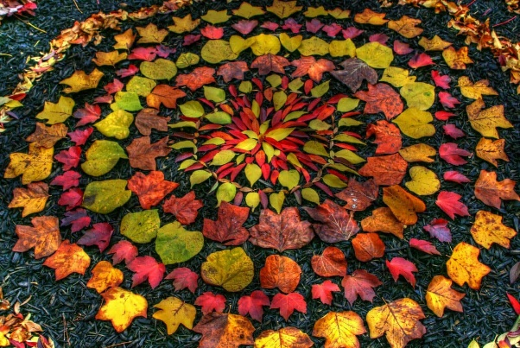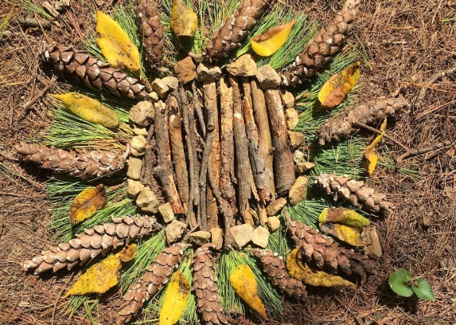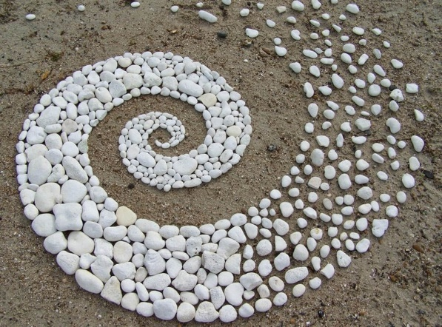

Please watch the following video of me explaining the assignment: https://www.youtube.com/watch?v=56BYYyCDvUo&t=2s
Students will create their own Andy Goldsworthy inspired artwork. They will gather materials from nature and arrange them outside into a sculpture. Remind students that this artwork will not stay forever. It will change overtime. Encourage them to go and look at it each day to see how the weather affects it! Below is my example as well as a student work sample. Please email a photo of your student’s work to me at econnor@newlifeacademyga.com. Please remember to include your student’s name and their homeroom teacher’s name in the email.
